The residents of Cateura, a town in Paraguay, live on top of a landfill that gets 1,500 tons waste each day, exposing the impoverished communities to unhealthy conditions. Most of the people in the town work in the dump as recyclers, including many of the young people.
When local teacher Favio Chavez decided to teach the town’s children to play music using his own instruments, he soon had more students than instruments. The solution? He started teaching the students on instruments upcycled from trash and the Recycled Orchestra was born.

Cateura, Paraguay, is a small city that has grown on top of a massive dump. It is regarded as one of the poorest slums in Latin America, a village where people live among a sea of garbage. Incredibly, the landfill itself is the primary form of subsistence for many residents, who pick through waste for items that can be used or sold. Prospects for most of the children born in Cateura is bleak as gangs and drugs await many of them.

A garbage picker named Nicolás Gómez (known as “Cola”) found a piece of trash that resembled a violin and brought it to musician Favio Chávez. Using other objects collected from the dump, the pair constructed a functional violin in a place where a real violin is worth more a house. Using items gleaned completely from the dump, the pair then built a cello, a flute, a drum, and suddenly had a wild idea: could a children’s orchestra be born in one of the most depressed areas in the world? Now a group of filmmakers, producers, and photographers are trying to tell the story of the orchestra through a documentary titled Landfill Harmonic. The orchestra seems poised to offer many of the children opportunities outside of the slum— they are already planning a multi-city tour around the U.S. The movie is currently being funded on Kickstarter and just passed the halfway mark today.

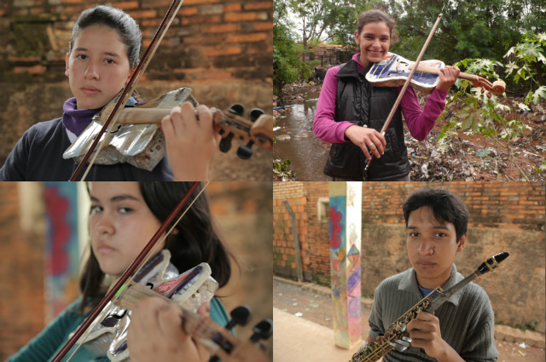

The sounds of a classical guitar come from two big jelly cans. Used X-rays serve as the skins of a thumping drum set. A battered aluminum salad bowl and strings tuned with forks from what must have been an elegant table make a violin. Bottle caps work perfectly well as keys for a saxophone. A chamber orchestra of 20 children uses these and other instruments fashioned out of recycled materials from a landfill where their parents eke out livings as trash-pickers, regularly performing the music of Beethoven and Mozart, Henry Mancini and the Beatles. A concert they put on for The Associated Press also featured Frank Sinatra's "My Way" and some Paraguayan polkas.
Rocio Riveros, 15, said it took her a year to learn how to play her flute, which was made from tin cans. "Now I can't live without this orchestra," she said.

'We're doing the impossible'
The youngsters of "The Orchestra of Instruments Recycled From Cateura" performed in Brazil, Panama and Colombia this year, and hope to play at an exhibit opening next year in their honor at the Musical Instrument Museum in Phoenix, Ariz.
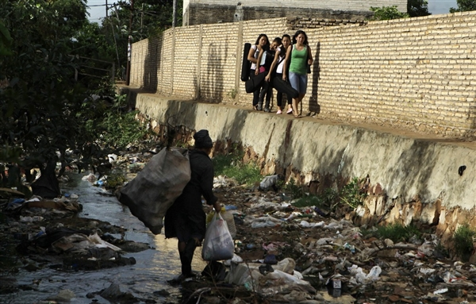

"We want to provide a way out of the landfill for these kids and their families. So we're doing the impossible so that they can travel outside Paraguay, to become renowned and admired," said Favio Chavez, the music teacher who started the orchestra.

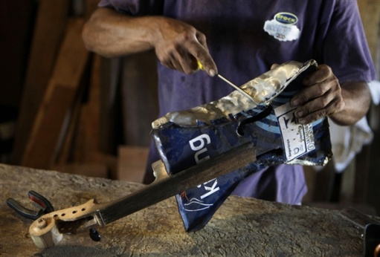

Making dreams a reality
The community of Cateura could not be more marginalized. But the music coming from garbage has some families believing in a different future for their children.

Gaeilge
Thosaigh daoine ag déanamh uirlisí nuair a fuair Nicolás Gómez píosa brúscar mar cruth de fidil. Thóg sé é don cheoilteóir Favio Chávez agus thosaigh Favio Chávez ag múineadh an ceol do na páistí.

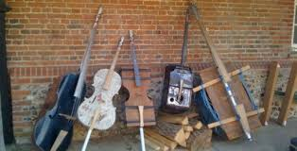
Seo é pictúir de cúpla uirlisí a bhí déanta acu.

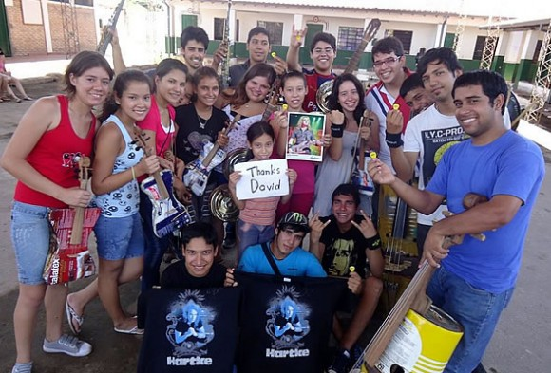

This is a picture of the orchestra with their instruments saying
“Thanks David!”

